Task 2.1:

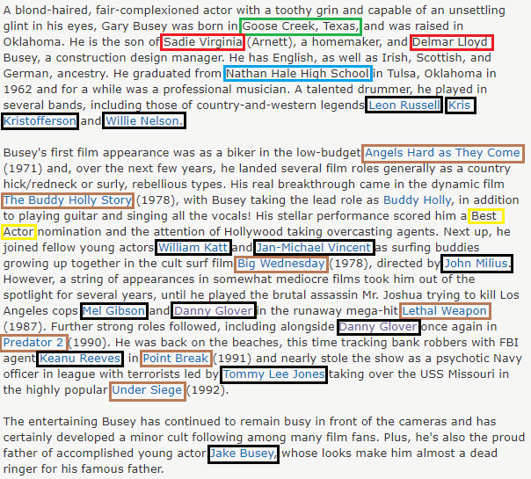

Task 2.2 extractors:

Lexical:

birthplace

pattern = [

{'ORTH': 'born'},

{'OP': '*'},

{'ORTH': 'in'},

{'OP': '*'},

{'IS_TITLE': True,},

{'IS_PUNCT': True,},

{'IS_TITLE': True,},

{'IS_PUNCT': True, 'OP': '?'},

{'IS_TITLE': True, 'OP': '?'},

{'IS_UPPER': True, 'OP': '?'},

]

isolate_pattern = [

{'IS_TITLE': True,},

{'IS_PUNCT': True, 'OP': '?'},

{'IS_TITLE': True, 'OP': '?'},

{'IS_PUNCT': True, 'OP': '?'},

{'IS_TITLE': True, 'OP': '?'},

{'IS_UPPER': True, 'OP': '?'},

]

Education

pattern = [

{'TEXT': {'REGEX': 'graduated|attended|enrolled'}},

{'OP': '*'},

{'TEXT': {'REGEX': 'School|College|University|Academy'}},

{'TEXT': 'of', 'OP': '?'},

{'IS_TITLE': True, 'OP': '*'},

{'IS_PUNCT': True, 'OP': '*'},

{'IS_TITLE': True, 'OP': '*'},

]

isolate_pattern = [

{'IS_TITLE': True, 'OP': '+'},

{'IS_STOP': True, 'OP': '?'},

{'IS_TITLE': True, 'OP': '+'},

]

Parents

pattern = [

{'LOWER': {'REGEX': '^(son|daughter|born)$'}},

# {'OP': '*'},

{'ORTH': {'REGEX': 'of|to'}},

{'OP': '*'},

{'IS_TITLE': True, 'OP': '+'},

{'OP': '*'},

{'ORTH': 'and'},

{'OP': '*'},

{'IS_TITLE': True, 'OP': '+'},

# {'IS_PUNCT': True,},

]

pattern2 = [

{'LOWER': {'REGEX': '^(mother|father|parent)$'}},

{'ORTH': ',',},

{'IS_TITLE': True, 'OP': '+'},

]

isolate_pattern = [

{'IS_TITLE': True},

{'IS_TITLE': True},

]

Awards

pattern = [

{'TEXT': {'REGEX': '^(nominated|nomination([s]?)|awarded|won)$'}},

{'IS_STOP': True, 'OP': '*'},

{'IS_TITLE': True, 'OP': '+'},

]

pattern2 = [

{'IS_TITLE': True, 'OP': '+'},

{'TEXT': {'REGEX': '^(nomination|award)([s]?)$'}},

]

isolate_pattern = [

{'IS_TITLE': True, 'OP': '+'},

]

Performances

pattern = [

{'IS_TITLE': True, 'OP': '+'},

{'IS_STOP': True, 'OP': '*'},

{'IS_TITLE': True, 'OP': '*'},

{'TEXT': '('},

{'LIKE_NUM': True},

{'TEXT': ')'},

]

Colleagues

pattern = [

{'LOWER': {'REGEX': '^(alongside|actor|actress|director|producer)'}},

{'IS_STOP': True, 'OP': '*'},

{'IS_TITLE': True, 'OP': '+'},

{'IS_STOP': True, 'OP': '*'},

{'IS_TITLE': True, 'OP': '*'},

]

isolate_pattern = [

{'IS_TITLE': True},

{'IS_TITLE': True, 'OP': '+'},

]

Syntactic

Birthplace

pattern = [

{'POS': 'VERB', 'ORTH': 'born'},

{'OP': '*'},

{'LOWER': 'in', 'POS': 'ADP'},

{'OP': '*'},

{'ENT_TYPE': 'GPE', 'OP': '+'},

]

Education

pattern = [

{'POS': 'VERB', 'LEMMA': {'REGEX': 'graduate|attend|enroll'}},

{'OP': '*'},

{'ENT_TYPE': 'ORG', 'TEXT': {'REGEX': 'School|College|University|Academy'}},

]

Parents

pattern = [

{'POS': 'NOUN', 'TEXT': {'REGEX': '^(son|daughter)$'}},

{'LOWER': 'of', 'POS': 'ADP'},

{'OP': '*'},

{'ENT_TYPE': 'PERSON', 'OP': '+'},

]

pattern2 = [

{'POS': 'NOUN', 'LOWER': {'REGEX': '^(mother|father|parent)$'}},

{'IS_PUNCT': True, 'OP': '?'},

{'ENT_TYPE': 'PERSON', 'OP': '+'},

]

pattern3 = [

{'POS': 'VERB', 'LOWER': 'born'},

{'LOWER': 'to', 'POS': 'ADP'},

{'OP': '*'},

{'ENT_TYPE': 'PERSON', 'OP': '+'},

]

Awards

pattern = [

{'POS': 'VERB', 'LEMMA': {'REGEX': '^(nominate|award|win)$'}},

{'IS_STOP': True, 'OP': '*'},

{'TAG': 'NNP', 'OP': '+'}

]

pattern2 = [

{'TAG': 'NNP', 'OP': '+'},

{'POS': 'NOUN', 'LEMMA': {'REGEX': '^(nomination|award)$'}},

]

Performances

pattern = [

{'IS_TITLE': True, 'OP': '+'},

{'IS_STOP': True, 'OP': '*'},

{'IS_TITLE': True, 'OP': '*'},

{'TEXT': '('},

{'LIKE_NUM': True},

{'TEXT': ')'},

]

Colleagues

pattern = [

{'LOWER': {'REGEX': '^(along|actor|actress|director|producer|with|including|directed)'}},

{'IS_STOP': True, 'OP': '*'},

{'ENT_TYPE': 'PERSON', 'OP': '+'},

{'IS_STOP': True, 'OP': '*'},

{'ENT_TYPE': 'PERSON', 'OP': '*'},

]

Task 2.3:

Was not able to calculate precision and recall